I have forked the file from Mohan’s source code and have made the same in the following:

Now, creating 4 Docker files for the four services (user service, product service, order service and gateway service)
The screenshots are as follows:
For user service:
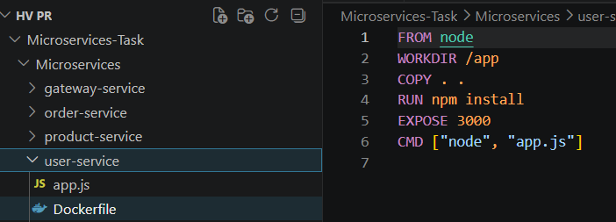

For product service:
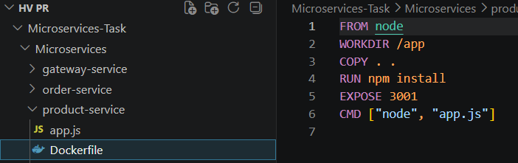

For order service:

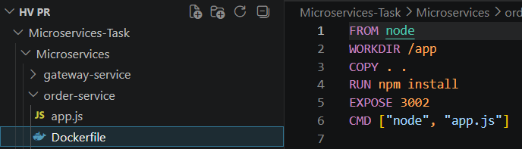

For gateway service:

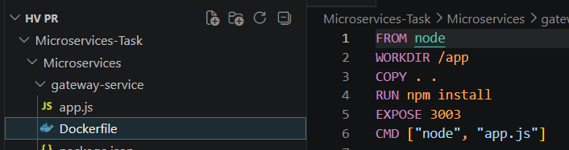

Now, I have created the Docker Compose file to containerize all the 4 services. Below is screenshot for the same.

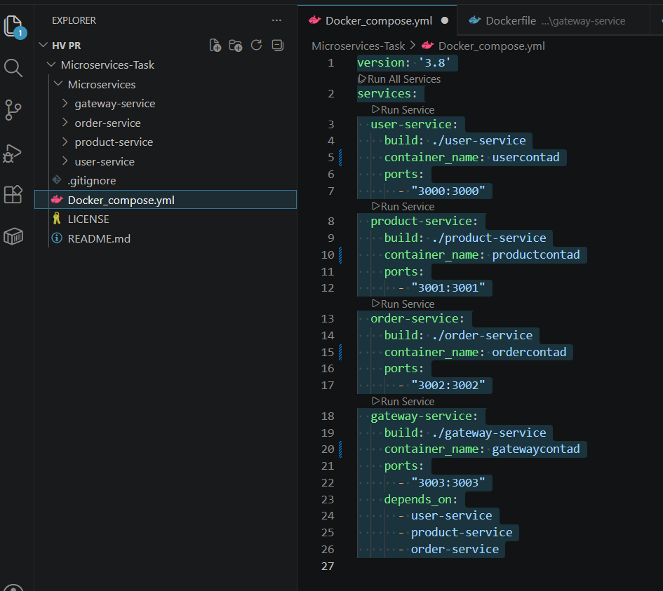

Post creation of the same the said .yml script has been executed in the below format using docker compose comand

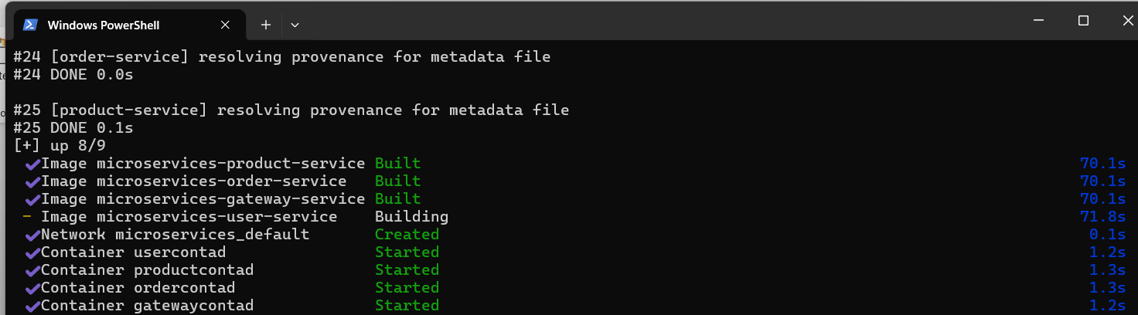
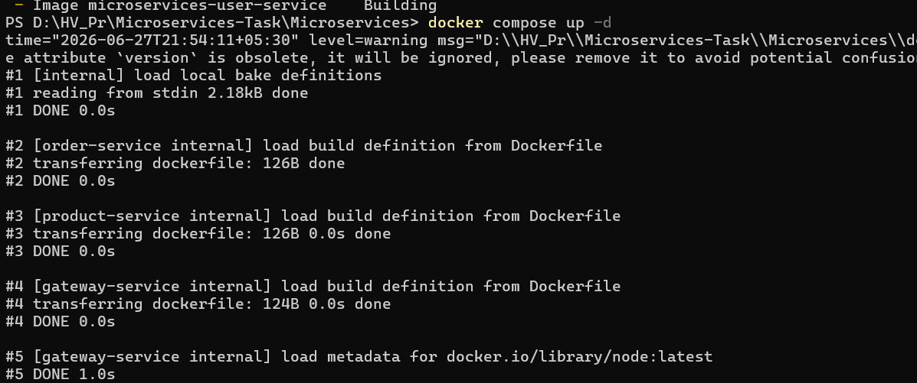

The containers that have been created are up and running

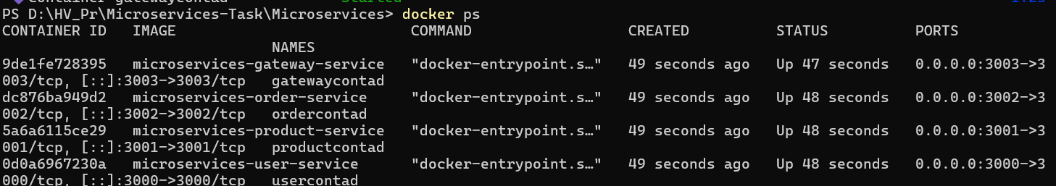

Microservices network is also up and running:
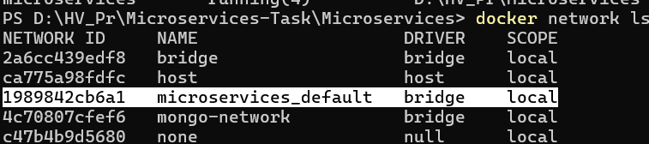

Test User Results are as follows:
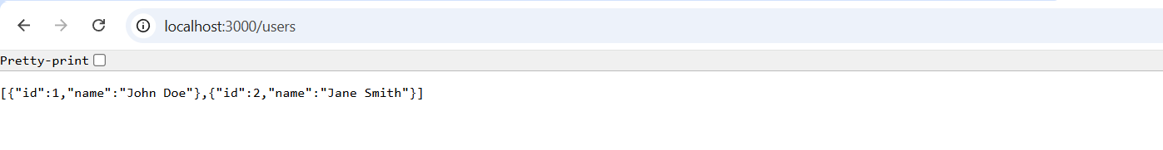

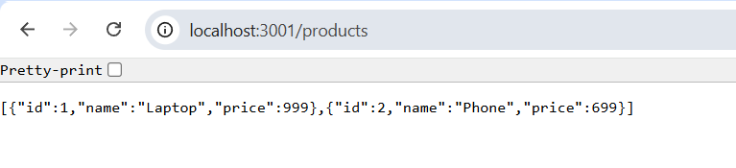

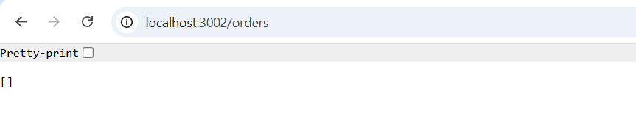

Gateway API accessibility
